Order Of Service

Singing: Psalm 51a—CW page 86

Reading: Psalm 31

Opening Hymn: TLH 98

Reading: Revelation 13

Request Hymn: CW Supplement 748

Reading: John 7:32-39

Sermon Hymn: CW 363

Sermon Text: Song Of Solomon 5:10

# 1
Prayer

The Apostles’ Creed, TLH page 12

Holy Communion

The Lord's Prayer

The Blessing

Closing Hymn: TLH 109

* * * * * * * * * * *

Bible Study: Lambs: Romans 8:37; More Than Conquerors
Sheep: Proverbs 12:20-24
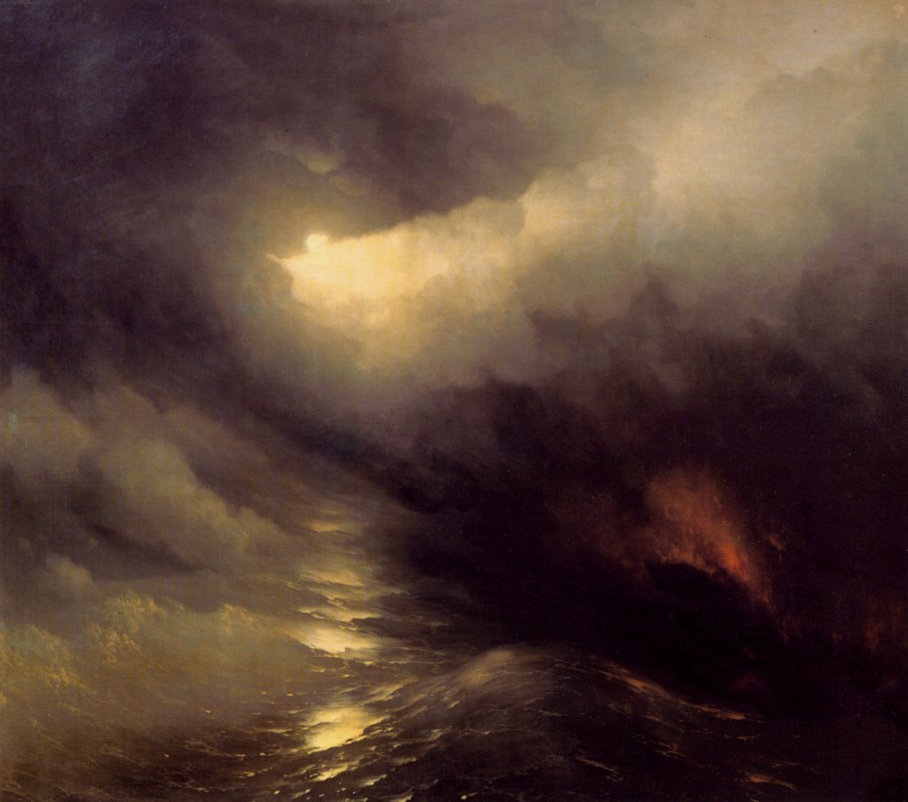

And There Was Light

Water
Of
Life
22 January 2017

W A T E R O F L I F E

Independent Christian Church—Conservative Lutheran Doctrine

Worship Service: 9:30 a.m. Bible Study: 10:45 a.m.

Larry Cooper, Pastor E-Mail address:
111 N. Ridge Road lcooper@wateroflife.cc
Coon Valley, WI 54623 Web Site:
Phone: (608) 452-2105 www.wateroflife.cc

* * * * * * * * * * * * * * * * * * * * * * * * * * *

Sermon Text: Song Of Solomon 5:10

# 1

* * * * * * * * * * * * * * * * * * * * * * * * * * *

Song of Solomon 5:10 My beloved is white and ruddy, the chiefest among ten thousand.

Night Visit—John 3:1-10

1 There was a man of the Pharisees, named Nicodemus, a ruler of the Jews: 2 The same came to Jesus by night, and said unto him, Rabbi, we know that thou art a teacher come from God: for no man can do these miracles that thou doest, except God be with him. 3 Jesus answered and said unto him, Verily, verily, I say unto thee, Except a man be born again, he cannot see the kingdom of God. 4 Nicodemus saith unto him, How can a man be born when he is old? can he enter the second time into his mother's womb, and be born? 5 Jesus answered, Verily, verily, I say unto thee, Except a man be born of water and of the Spirit, he cannot enter into the kingdom of God. 6 That which is born of the flesh is flesh; and that which is born of the Spirit is spirit. 7 Marvel not that I said unto thee, Ye must be born again. 8 The wind bloweth where it listeth, and thou hearest the sound thereof, but canst not tell whence it cometh, and whither it goeth: so is every one that is born of the Spirit. 9 Nicodemus answered and said unto him, How can these things be? 10 Jesus answered and said unto him, Art thou a master of Israel, and knowest not these things?

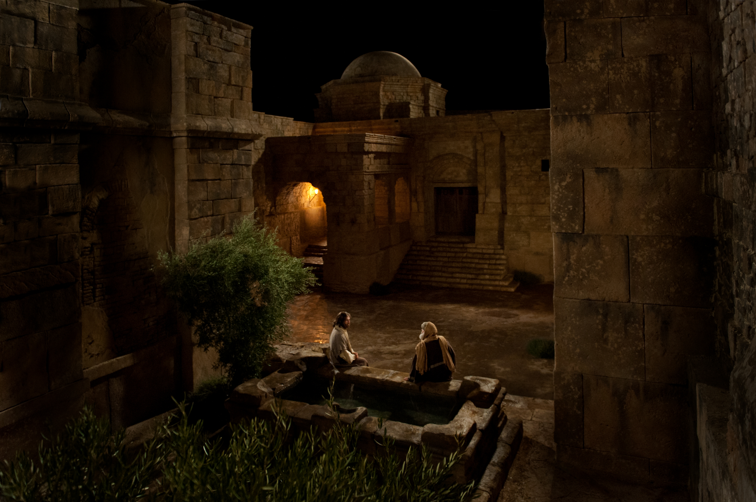

The question which Christ asked of Nicodemus could also be asked of the Daughters of Jerusalem. They had put the question to the Bride—“What is thy beloved more than another beloved?” And the Bride could rightly answer—“Art thou the Daughters of Jerusalem, and knowest not these things?”

Spiritual darkness in high places is no new thing.

